**Personal Portfolio Website using HTML, CSS, and JavaScript**

**🎯 Aim**

The aim of this project is to design and develop a simple and responsive portfolio website using HTML, CSS, and JavaScript. The website showcases a personal or professional profile with three key sections — Home, About Us, and Contact Information. It serves as a digital resume or identity page for students, developers, freelancers, or job seekers who wish to establish their online presence.

This project is aimed at beginners to help them understand the structuring of multi-section webpages, applying consistent styling using CSS, and enabling basic interactivity using JavaScript. It also reinforces good web design practices including navigation, layout, and responsiveness.

🎯 Objective

* To create a multi-section webpage with Home, About Us, and Contact Info.
* To design a clean and modern interface that is easy to navigate.
* To use CSS styling for layout, font styles, and responsiveness.
* To implement JavaScript for interactive navigation or dynamic content.
* To build a foundation for more advanced portfolio projects.

🛠️ Project Steps

1. Set up a HTML structure with sections for Home, About Us, and Contact.
2. Add a navigation bar for quick access to each section.
3. Use CSS for layout design, font styling, spacing, and color themes.
4. Include a simple JavaScript function to highlight active navigation items.
5. Populate content for About section (e.g., education, skills).
6. Add a basic contact form with name, email, and message input fields.
7. Test on various devices to ensure responsive design.

**💻 Code**

**✅ HTML**

<!DOCTYPE html>

<html lang="en">

<head>

<meta charset="UTF-8" />

<meta name="viewport" content="width=device-width, initial-scale=1.0"/>

<title>My Portfolio</title>

<link rel="stylesheet" href="110.css" />

</head>

<body>

<nav>

<ul>

<li><a href="#home" class="active">Home</a></li>

<li><a href="#about">About Us</a></li>

<li><a href="#contact">Contact</a></li>

</ul>

</nav>

<section id="home">

<h1>Hello, I'm Alex!</h1>

<p>Welcome to my personal portfolio website.</p>

</section>

<section id="about">

<h2>About Me</h2>

<p>I am a passionate web developer skilled in HTML, CSS, and JavaScript. I enjoy building interactive websites and learning new technologies.</p>

<ul>

<li><strong>Education:</strong> B.Tech in Computer Science</li>

<li><strong>Skills:</strong> Web Design, JavaScript, Git</li>

<li><strong>Projects:</strong> Portfolio Website, Student Timetable Viewer</li>

</ul>

</section>

<section id="contact">

<h2>Contact Me</h2>

<form>

<label for="name">Name:</label><br />

<input type="text" id="name" name="name" required><br />

<label for="email">Email:</label><br />

<input type="email" id="email" name="email" required><br />

<label for="message">Message:</label><br />

<textarea id="message" name="message" rows="4" required></textarea><br />

<button type="submit">Submit</button>

</form>

</section>

<script src="10.js"></script>

</body>

</html>

🎨 CSS

body {

font-family: Arial, sans-serif;

margin: 0;

padding: 0;

background: #f5f5f5;

color: #333;

}

nav {

background-color: #333;

padding: 10px 0;

}

nav ul {

list-style: none;

display: flex;

justify-content: center;

}

nav ul li {

margin: 0 15px;

}

nav ul li a {

color: white;

text-decoration: none;

font-weight: bold;

padding: 5px 10px;

}

nav ul li a.active,

nav ul li a:hover {

background-color: #ff9800;

border-radius: 5px;

}

section {

padding: 40px;

text-align: center;

}

#about ul {

list-style: none;

padding: 0;

}

form {

display: inline-block;

text-align: left;

margin-top: 20px;

}

form input, form textarea {

width: 100%;

padding: 8px;

margin-bottom: 10px;

}

form button {

padding: 10px 20px;

background-color: #ff9800;

color: white;

border: none;

cursor: pointer;

}

✨ JavaScript

const links = document.querySelectorAll('nav a');

links.forEach(link => {

link.addEventListener('click', function() {

links.forEach(el => el.classList.remove('active'));

this.classList.add('active');

});

});

🖼️ **Output**

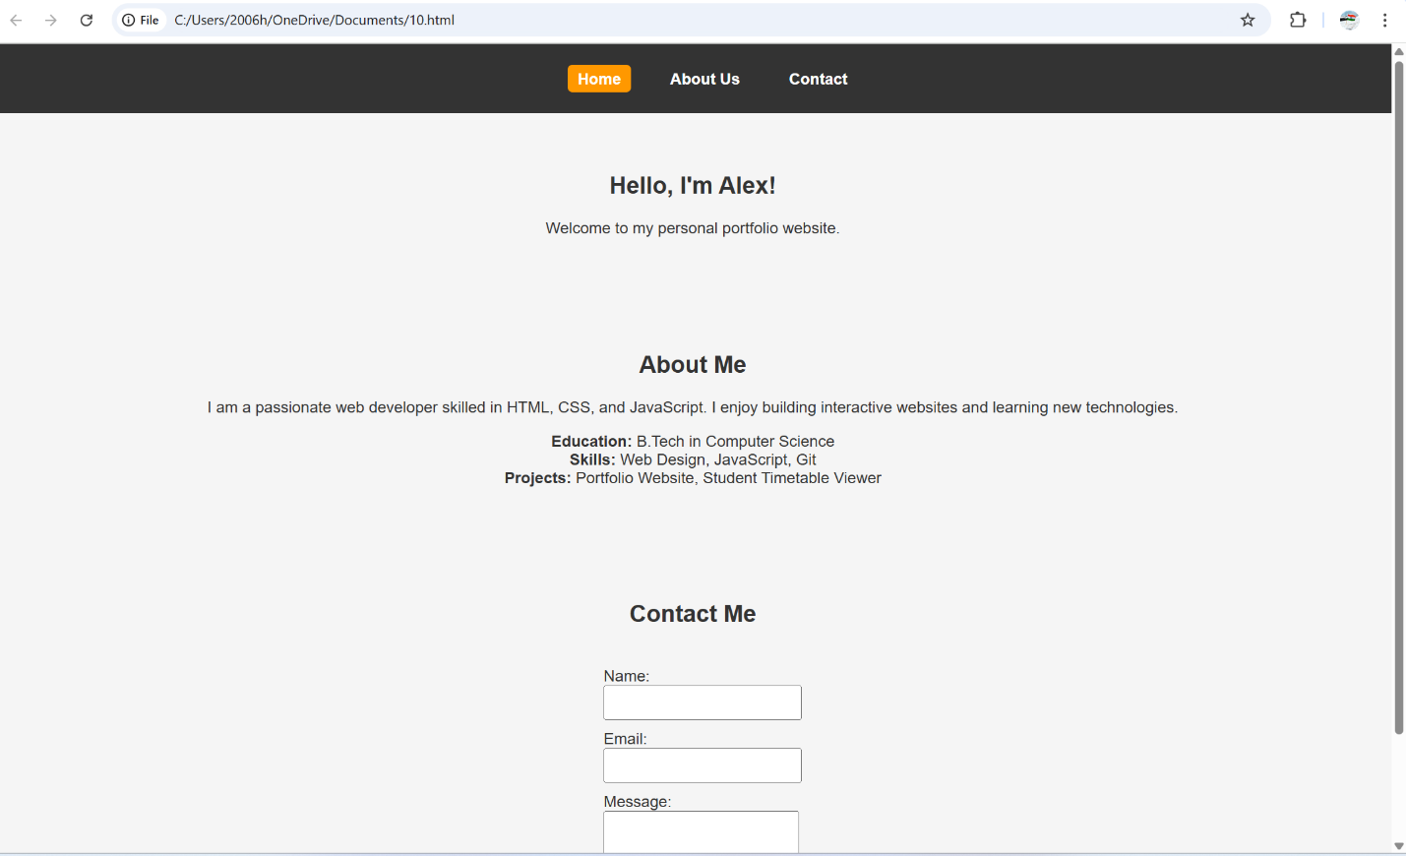

**🎓 Learning Outcomes**

By completing this project, students will:

* Learn to **structure a multi-page layout** within a single HTML document.
* Use **CSS** to style and format text, layouts, and navigation menus.
* Understand **JavaScript event listeners** for interactivity (e.g., highlighting active nav).
* Develop a **basic contact form** using HTML elements.
* Gain experience in building a **personal branding webpage**.
* Understand how to build and style **responsive front-end websites**